GISG 130 Introduction to Remote Sensing

Final Project Report

Project Title: Results Supervised Classification of the Dalworthington Garden in Tarrant county, Texas

Introduction
Objective:
Dalworthington Gardens is a city in Tarrant County, Texas, United States and a suburb of Arlington. The population was 2,259 at the 2010 census. Pick this one for small area of studies to see the changes using remoted sensing technics learn in class expecting minor areas and some almost stay identical and made into a company type project to keep a formal analysis have a audience in mind. Area in google maps links:

https://www.google.com/maps/place/Dalworthington+Gardens,+TX/@32.6941489,-97.1760512,14z/data=!3m1!4b1!4m5!3m4!1s0x864e634ab694dde9:0x8fe74fb26ce8fd2!8m2!3d32.7029556!4d-97.1553612?hl=en

https://tools.wmflabs.org/geohack/geohack.php?pagename=Dalworthington_Gardens,_Texas&params=32_41_48_N_97_9_21_W_region:US_type:city link

Methods
Land sat 8 of study areas 210215 and 2018.
Set environment gathered rest data from ESRI like counties layer and state.
Took the imagery and set classification on supervised on both set it on pixels and went on identifying areas ,I reclassified tool and major filter tool 2 time on both years used boundary clean but still get problems in it took a moment to reclass without errors and had problem with symbology changes. then went to create a line in the studies area in used topographic map to trace the lines and set geo cords after in new set feature.
Used raster clip but keep having problem on to trace it in the line keep trying for a wild no solution for the moment. Went on with the near result of it.
Then used calculating land convert tool Intergern tool and summary tactics to come up with my analysis and conclusion of the area.
Discuss the pre-processing and analysis techniques in your project.
Took me a wild to process them instead and the expected results had to keep trying in order to not get errors in classified and geo coordinate in feature had a lot a wait times and took make computer for along hold but made it work at least need to make more early plans and less work.

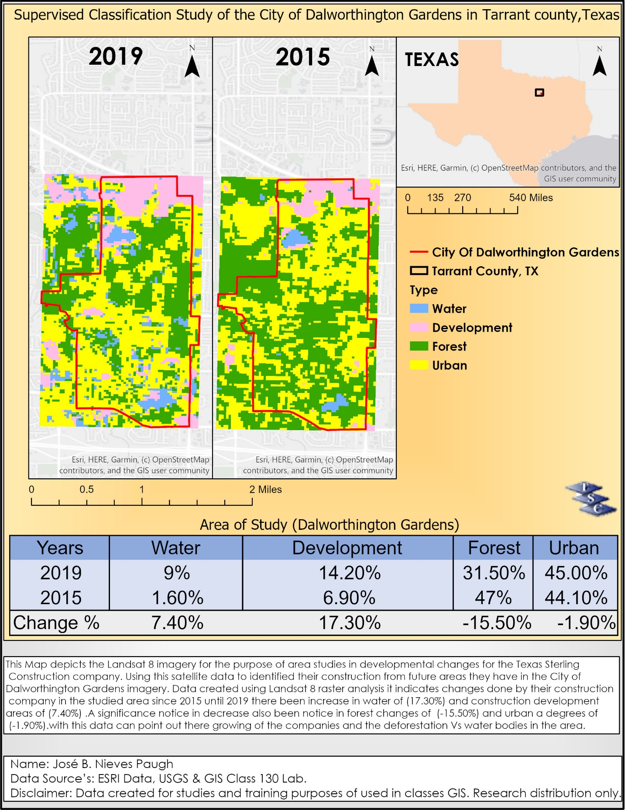

Discussion and Conclusion
Discuss and interpret your results in the context of the project background. This Map depicts the Landsat 8 imagery took a wild to download for the purpose of area studies in developmental changes was not expecting much since been a small area of studies using the data gather to identified areas in the City of Dalworthington Gardens imagery. Follow a company’s type studies in order to make it feel more professional Data created using Landsat 8 raster analysis to it indicates changes done by their construction company in the studied area since 2015 until 2019 there been increase in water of (17.30%) and construction development areas of (7.40%) .A significance notice in decrease also been notice in forest changes of (-15.50%) and urban a degrees of (-1.90%).with this data can point out there growing of the companies and the deforestation Vs water bodies in the area. Did the results of your study agree with your initial expectations or other studies? No, I expected less changes due area been smaller.
What challenges did you have? I had problems with the raster clip and waiting to load when applying changes and computer slowdown or program shutdown.
Include recommendations for future studies for future studies? I wan to implement it in Yellow stone after I get ack and get me a great work station to process a high surfer area of studies.
how your analysis could be improved? Be more direct on it and timely manner.
what you would do differently next time? I would d add more model builder or python.

CITE your data – this means your images, GIS data, and any additional research.
https://www.usgs.gov/centers/eros/data-citation?qt-science_support_page_related_con=0#qt-science_support_page_related_con
https://texassterling.com/ LOGO.
https://services.arcgis.com/P3ePLMYs2RVChkJx/arcgis/rest/services/USA_Counties/FeatureServer
https://earthexplorer.usgs.gov/ land sat 8 data of the area of studies.
https://en.wikipedia.org/wiki/Dalworthington_Gardens,_Texas
https://tools.wmflabs.org/geohack/geohack.php?pagename=Dalworthington_Gardens,_Texas&params=32_41_48_N_97_9_21_W_region:US_type:city

